Stacks/Queue. Normal
Stacks/Queue. Normal  - Design a queue using an array.  - Implement two stacks in an array.  - Balanced parentheses.  - Postfix expression  - Permutations.  - Combinations. - w/o  - Find moving averages and maximums. | Stacks/Queues. Advanced  - Queue with two stacks.  - Stack with two queues.  - Stack with max.  - Infix to Postfix Conversion.  - King and Knight. - w/o  - Duplicate parenthesis.  - Implement LRU Cache. - w/o

- Design a queue using an array. Develop the push | pop | peek | isEmpty functions for a queue using an array as the internal data structure.
Solution using a circular array http://oppansource.com/queue-implementation-in-java-using-circular-array/
Possible java solution:
public static class MyQueue {
public static final int DEFAULT_SIZE=5;
private Object data[];
private int index;
public MyQueue(){
data=new Object[DEFAULT_SIZE];
}
public boolean isEmpty(){
return index==0;
}
public void enqueue(Object obj) throws Exception{
if (index==DEFAULT_SIZE-1){
throw new Exception("Queue is full. Dequeue some objects");
}
this.data[index]=obj;
this.index++;
}
public Object dequeue() throws Exception{
if (isEmpty()) throw new Exception("Queue is empty");
Object obj=this.data[0];
for (int i =0; i<this.index-1; i++){
data[i]=data[i+1];
}
this.index--;
return obj;
}
}

Upgrade the solution by making the array expandable and not fixed size.
- Implement two stacks in an array. Create a data structure twoStacks that represents two stacks. Implementation of twoStacks should use only one array, i.e., both stacks should use the same array for storing elements. Following functions must be supported by twoStacks.
push1(int x) –> pushes x to first stack
push2(int x) –> pushes x to second stack
pop1() –> pops an element from first stack and return the popped element
pop2() –> pops an element from second stack and return the popped element
Solutions:
Method 1 (Divide the space in two halves)
A simple way to implement two stacks is to divide the array in two halves and assign the half half space to two stacks, i.e., use arr[0] to arr[n/2] for stack1, and arr[n/2+1] to arr[n-1] for stack2 where arr[] is the array to be used to implement two stacks and size of array be n.
The problem with this method is inefficient use of array space. A stack push operation may result in stack overflow even if there is space available in arr[]. For example, say the array size is 6 and we push 3 elements to stack1 and do not push anything to second stack2. When we push 4th element to stack1, there will be overflow even if we have space for 3 more elements in array.

Method 2 (A space efficient implementation)
This method efficiently utilizes the available space. It doesn’t cause an overflow if there is space available in arr[]. The idea is to start two stacks from two extreme corners of arr[]. stack1 starts from the leftmost element, the first element in stack1 is pushed at index 0. The stack2 starts from the rightmost corner, the first element in stack2 is pushed at index (n-1). Both stacks grow (or shrink) in opposite direction. To check for overflow, all we need to check is for space between top elements of both stacks. This check is highlighted in the below code.

#include<iostream>  #include<stdlib.h>  using namespace std;  class twoStacks {  int *arr;  int size;  int top1, top2;  public:  twoStacks(int n) // constructor  {  size = n;  arr = new int[n];  top1 = -1;  top2 = size;  }  // Method to push an element x to stack1  void push1(int x)  {  // There is at least one empty space for new element  if (top1 < top2 - 1)  {  top1++;  arr[top1] = x;  }  else  {  cout << "Stack Overflow";  exit(1);  }  }  // Method to push an element x to stack2  void push2(int x)  {  // There is at least one empty space for new element  if (top1 < top2 - 1)  {  top2--;  arr[top2] = x;  }  else  {  cout << "Stack Overflow";  exit(1);  }  } | //Method to pop an element from first stack  int pop1()  {  if (top1 >= 0 )  {  int x = arr[top1];  top1--;  return x;  }  else  {  cout << "Stack UnderFlow";  exit(1);  }  }  // Method to pop an element from second stack  int pop2()  {  if (top2 < size)  {  int x = arr[top2];  top2++;  return x;  }  else  {  cout << "Stack UnderFlow";  exit(1);  }  }  };  /* Driver program to test twoStacks class */  int main()  {  twoStacks ts(5);  ts.push1(5);  ts.push2(10);  ts.push2(15);  ts.push1(11);  ts.push2(7);  cout<<"Popped element from stack1 is "<<ts.pop1();  ts.push2(40);  cout<<"Popped element from stack2 is "<<ts.pop2();  return 0;  }

Output:
Popped element from stack1 is 11
Popped element from stack2 is 40
Time complexity of all 4 operations of twoStack is O(1).
- Balanced parentheses. Write a function which checks if parentheses in a given expression are balanced.
Example: 1) input: (5+6)*(7+8)/(4+3) output: balanced
2) input: (4+5)*(2+(4-7) output: not balanced
Solution (http://interactivepython.org/runestone/static/pythonds/BasicDS/stacks.html)
- Starting with an empty stack, process the string from left to right
- If a char is an opening parenthesis, push it on the stack as a signal that a corresponding closing symbol needs to appear later
- If, on the other hand, a symbol is a closing parenthesis, pop the stack. As long as it is possible to pop the stack to match every closing symbol, the parentheses remain balanced
- If at any time there is no opening symbol on the stack to match a closing symbol, the string is not balanced properly
- At the end of the string, when all symbols have been processed, the stack should be empty

from pythonds.basic.stack import Stack
def parChecker(symbolString):
s = Stack()
balanced = True
index = 0
while index < len(symbolString) and balanced:
symbol = symbolString[index]
if symbol == "(":
s.push(symbol)
elif symbol == ")":
if s.isEmpty():
balanced = False
else:
s.pop()
index = index + 1
if balanced and s.isEmpty():
return True
else:
return False

To modify this code for different types of parenthesis, extra functions is_parenthesis(char) and is_paranthesis_pair(chat, char) should be added.
- Postfix expression Given an expression in postfix notation evaluate it. In postfix notation operands are followed by operations. For example, X+Y becomes XY+ in postfix notation. Example: 1) input: 5 6 + output: 11 2) input: 23 17 + 45 5 - - output: 0
Solution:
- Passing through the expression, read an item:
  - If the item is a number, push it onto the argument stack
  - if the item is an operator:
    - pop the last 2 arguments and evaluate them with the item/operator
    - push the result to the argument stack
- Return the last element in the stack
Possible java example:
public static int calculate(String s)
{
int n,r=0;
Stack<Integer> a=new Stack<Integer>();

StringTokenizer st = new StringTokenizer(s);

while(st.hasMoreTokens())
{
String item = st.nextToken();
try {
a.push(Integer.parseInt(item));
}
catch (NumberFormatException nfe)
{
int x=a.pop();
int y=a.pop();
switch(item)
{
case "+":r=x+y;
break;
case "-":r=y-x;
break;
case "*":r=x*y;
break;
case "/":r=y/x;
break;
default:r=0;
}
a.push(r);
}
}
r=a.pop();
return(r);
}
}
- Permutations. Print all permutations of N elements in an array.

Here is an implementation for an array of char (ie, a string).
Note that this has odd behavior with redundant letters in the string.

#define swap(a,b,t) (t=(a),a=(b),b=(t))
void permute_aux(char *orig, char *str, int len)
{
int i;
char ch;
if (len == 0) return;
if (len == 1) { /* bottom of recursion, print! */
printf("%s\n", orig);
return;
}
/* Keep first char constant, permute remainder of string */
permute_aux(orig, str+1, len-1);
for (i = 1; i < len; i++) { /* for each remaining letter… */
swap(str[0], str[i], ch); /* ...swap it into first char… */
permute_aux(orig, str+1, len-1); /* ...recurse… */
swap(str[0], str[i], ch); /* ...and restore str */
}
}
void permute(char *str)
{
permute_aux(str, str, strlen(str));
}

- Combinations. Print all combinations of N elements in an array (each element is chosen at most once in any combination).
- Find moving averages and maximums. Given an infinite stream of numbers in time order, at any given time:
- Find moving averages of the last K numbers.

A possible solution for just finding the average of the last K numbers:
#define WINDOW_SIZE 3 /* "K" */
typedef int data_t; /* data type of the input stream (int,float,double) */
static data_t sum; /* default init to 0 */
static int len; /* default init to 0 */

/* We keep the queue as an array: head points to oldest in queue,
* tail points to where next item will be added. Use window_size+1
* so there is room to enqueue one before dequeueing. */
static data_t q[WINDOW_SIZE+1];
static int head, tail; /* default init to 0 */

/* Enqueue a new data item by pushing it onto the queue
* Update the sum and len of the window.
* If our window is full, dequeue an item from the queue */
void AddNewData(data_t d)
{
/* Update sum of all items in window, as well as count of items */
sum += d;
len++;
q[tail++] = d; /* Push new item on queue */
if (tail > WINDOW_SIZE) tail = 0;
if (len > WINDOW_SIZE) { /* Remove an item from the queue */
len--; /* is also one out of window */
sum -= q[head++]; /* update sum while dequeueing */
if (head > WINDOW_SIZE) head = 0;
}
}

/* Return the current average of items in the window.
* We are tracking the sum, and the count. Just divide for average */
data_t FindAverage()
{
if (len == 0) return 0; /* some sort of error/nonsense */
return sum / ((data_t) len);
}

- Find the maximums of the last K numbers (maybe medium problem)

The best solution for tracking the max of a moving window is to use two stacks to implement the queue, but make them both “Stack with Max”. The implementation here also does the Average. This is provably O(n) average case for tracking the max, though the worst case instantaneous cost can be O(k) for one data item, but that can’t happen more than 1/k time, hence the long term average of O(1) per data item passing through the queue. The Max and Ave come back in O(1) time.

#define WINDOW_SIZE 3 /* "K" */
typedef int data_t; /* data type of the input stream (int,float,double) */
static data_t sum; /* default init to 0 */
static int len; /* default init to 0 */

typedef struct maxstackitem {
data_t val;
data_t max;
} maxStackItem;

/* We keep the stacks as arrays, with a pointer to one above the
* top of the stack (that is, Idx is invalid, Idx-1 is top item */
static maxStackItem inStack[WINDOW_SIZE+1], outStack[WINDOW_SIZE+1];
static int inIdx, outIdx; /* default init to 0 */

/* Enqueue a new data item by pushing it onto inStack
* Update the sum and len of the window.
* If our window is full, dequeue an item from the outStack
* If outStack is empty, fill it from inStack */
void AddNewData(data_t d)
{
sum += d; /* Update sum and count of all items in window */
len++;
/* Push new item on inStack */
inStack[inIdx].val = d;
inStack[inIdx].max = d; /* initialize field */
if (inIdx > 0 && d < inStack[inIdx-1].max)
inStack[inIdx].max = inStack[inIdx-1].max; /* update max */
inIdx++;

if (len > WINDOW_SIZE) { /* Remove an item from outStack. Refill outStack if it's empty */
if (outIdx == 0) {
while (inIdx > 0) {/* Pop an item off inStack, push it on outStack */
data_t t;
inIdx--;
t = inStack[inIdx].val;
outStack[outIdx].val = t;
outStack[outIdx].max = t;
if (outIdx > 0 && t < outStack[outIdx-1].max)
outStack[outIdx].max = outStack[outIdx-1].max;
outIdx++;
}
}
/* Throw away top item of outStack */
outIdx--; /* one out of outStack */
len--; /* is also one out of window */
sum -= outStack[outIdx].val; /* so update sum, too */
}
}

/* Return the current Max in the window, which is just the larger
* of the two maxes on the inStack and outStack */
data_t FindMax()
{
data_t retval;
if (len <= 0) return 0; /* some form of error/nonsense */
if (inIdx > 0) { /* something on inStack, check max */
retval = inStack[inIdx-1].max;
if (outIdx > 0 && outStack[outIdx-1].max > retval)
retval = outStack[outIdx-1].max;
} else {
retval = outStack[outIdx-1].max;
}
return retval;
}

/* Return the current average of items in the window.
* We are tracking the sum, and the count. Just divide for average
*/
data_t FindAverage()
{
if (len == 0) return 0; /* some sort of error/nonsense */
return sum / ((data_t) len);
}

Stacks/Queues. Advanced
Stacks/Queue. Normal  - Design a queue using an array.  - Implement two stacks in an array.  - Balanced parentheses.  - Postfix expression  - Permutations.  - Combinations. - w/o  - Find moving averages and maximums. | Stacks/Queues. Advanced  - Queue with two stacks.  - Stack with two queues.  - Stack with max.  - Infix to Postfix Conversion.  - King and Knight. - w/o  - Duplicate parenthesis.  - Implement LRU Cache. - w/o

- Queue with two stacks. Implement a queue with two stacks so that each queue operations takes a constant amortized number of stack operations.
Possible solution:
Two stacks inbox and outbox
Enqueue: Push the new element onto inbox
Dequeue:
- If outbox is empty, refill it by popping each element from inbox and pushing it onto outbox
- Pop and return the top element from outbox
Using this method, each element will be in each stack exactly once - meaning each element will be pushed twice and popped twice, giving amortized constant time operations.
- Stack with two queues. Implement a stack with two queues.
Possible solution:
Two queues inbox and outbox
Push: Enqueue in inbox

Pop:
- If outbox is empty, dequeue all but one element from inbox to outbox
- Save the last element from outbox to return
- Switch the names of 2 queues
- Stack with max. Create a data structure that efficiently supports the stack operations (push and pop) and also a return-the-maximum operation. Assume the elements are real numbers so that you can compare them.
Solution (from “Cracking the Coding Interview”)
You can implement this by having each node in the stack keep track of the maximum beneath itself. Then, to find the max, you just look at what the top element thinks is the max. When you push an element onto the stack, the element is given the current maximum. It sets its “local max” to be the max.
public class StackWithMax extends Stack<NodeWithMax> {
public void push(int value) {
int newMax = Math.max(value, max());
super.push(new NodeWithMax(value, newMax));
}
public int max() {
if (this.isEmpty()) {
return Integer.MIN_VALUE;
}
else {
return peek().max;
}
}
}

class NodeWithMax {
public int value;
public int max;
public NodeWithMax(int v, int max){
value = v;
this.max = max;
}
}

There’s just one issue with this: if we have a large stack, we waste a lot of space by keeping
track of the max for every single element. Can we do better? We can (maybe) do a bit better than this by using an additional stack which keeps track of the maxs.
public class StackWithMax2 extends Stack<Integer> {
Stack<Integer> s2;
public StackWithMax2() {
s2 = new Stack<Integer>();
}
public void push(int value){
if (value >= max()) {
s2.push(value);
}
super.push(value);
}
public Integer pop() {
int value = super.pop();
if (value == max()) {
s2.pop();
}
return value;
}
public int max() {
if (s2.isEmpty()) {
return Integer.MIN_VALUE;
} else {
return s2.peek();
}
}
}

Why might this be more space efficient? If many elements have the same local max, then
we’re keeping a lot of duplicate data. By having the maxs kept in a separate stack, we don’t
have this duplicate data (although we do use up a lot of extra space because we have a stack
node instead of a single int.
- Infix to Postfix Conversion. Given an expression in infix notation return it in postfix notation. An infix expression is one in which operators are located between their operands. In postfix notation, the operator immediately follows its operands. ‘X + Y’ becomes ‘XY+’ in postfix notation. Example: 1) input: 3+4 output: 3 4 +
2) input: (300+23)*(43-21)/(84+7) output: 300 23 + 43 21 - * 84 7 + /
Solution from http://interactivepython.org/runestone/static/pythonds/BasicDS/stacks.html
Assume the infix expression is a string of tokens delimited by spaces. The operator tokens are *, /, +, and -, along with the left and right parentheses, ( and ). The operand tokens are the single-character identifiers A, B, C, and so on. The following steps will produce a string of tokens in postfix order.
- Create an empty stack called opstack for keeping operators. Create an empty list for output.
- Convert the input infix string to a list by using the string method split.
- Scan the token list from left to right.
  - If the token is an operand, append it to the end of the output list.
  - If the token is a left parenthesis, push it on the opstack.
  - If the token is a right parenthesis, pop the opstack until the corresponding left parenthesis is removed. Append each operator to the end of the output list.
  - If the token is an operator, *, /, +, or -, push it on the opstack. However, first remove any operators already on the opstack that have higher or equal precedence and append them to the output list.
- When the input expression has been completely processed, check the opstack. Any operators still on the stack can be removed and appended to the end of the output list.
"( A + B ) * ( C + D )" -> 'A B + C D + *'
Possible java solution:
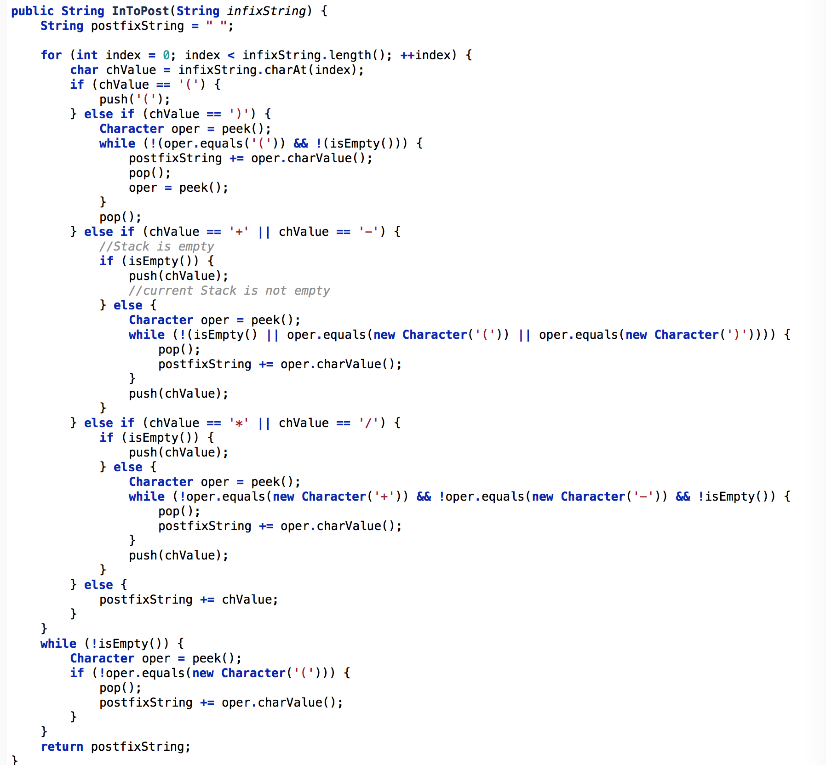
- King and Knight. Given a king and a knight on an infinite chessboard (no boundary), each takes turn to move (i.e. the king moves first, then the knight can move, then the king moves again and so on). Find the minimum number of moves until they meet at the same square.
- Duplicate parenthesis. Give an algorithm for finding duplicate parenthesis in a expression. Example: {{ (( a + b ) * (( c + d ))) }}
A simple solution follows, only supporting regular parentheses. It could be extended to handle multiple different types of (), [], {}, etc. It only works correctly with balanced parentheses, but an error message is emitted if they are not balanced. Definition of “redundant” is taken at its most primitive -- any non-whitespace counts as something meaningfully surrounded, so ‘(a)’ is not considered redundant.

#define MAX_DEPTH 100
typedef enum { LEFT_P, OTHER } paren_type;
typedef struct stackitem {
paren_type ch;
int str_index;
} stackItem;

/* We keep the stacks as arrays, with a pointer to one above the
* top of the stack (that is, Idx is invalid, Idx-1 is top item */
static stackItem Stack[MAX_DEPTH+1];
static int Idx; /* default init to 0 */

/* Enqueue a new data item by pushing it onto Stack */
void findRedundantParens(char *orig)
{
char *str = orig;
char ch;
if (str == NULL) return; /* empty string for input */

/* Push new item on inStack */
for (ch = *str; ch; ch = *++str) {
if (ch == '(') {
Stack[Idx].ch = LEFT_P;
Stack[Idx].str_index = str - orig;
Idx++;
} else if (ch == ')') {
if (Idx <= 0) {
printf("extra closing parenthesis at position %ld\n", str - orig);
} else if (Stack[Idx-1].ch == OTHER) { /* good! */
Idx--; /* pop OTHER off stack */
if (Idx == 0 || Stack[Idx-1].ch != LEFT_P)
printf("mismatched parenthesis at position %ld\n", str - orig);
if (Idx > 0)
Idx--; /* pop LEFT_P off stack */
} else { /* redundant found! */
printf("redundant parens found at positions %d and %ld\n",
Stack[Idx-1].str_index, str - orig);
Idx--; /* pop matching LEFT_P */
}
} else if (ch != ' ' && ch != '\t' && ch != '\n') {
if (Stack[Idx-1].ch != OTHER) {
Stack[Idx].ch = OTHER;
Stack[Idx].str_index = str - orig;
Idx++;
}
}
if (Idx > MAX_DEPTH) {
printf("stack overflow. Aborting!\n");
return;
}
}
}

